**16720 Computer Vision**

**Homework 4**

**Ruixin Liu**

**4/9/2019**

**Q1.1: Show that if the image coordinates are normalized so that the coordinate origin (0,0) coincides with the principal point, the F33 element of the fundamental matrix is zero.**

The given condition is that the coordinate origin coincides with the principal point. This means that these two points are a pair of correspondences and they satisfy:

As we know the coordinates of the principal point and the origin are both (0,0,1), we can write the equation:

Executing the multiplication, we get:

**Q1.2: Show that the epipolar lines in the two cameras are also parallel to the x-axis. Backup your argument with relevant equations.**

In order to calculate the epipolar line, we first calculate the Essential Matrix:

Since the position change of the cameras are only a pure translation parallel to the x axis, and . After doing cross-product of t we get . Then we have the Essential Matrix:

Assume a point on the left image plane, the corresponding epipolar line is:

Since the first row of the epipolar line is zero, the line is parallel to x axis.

**Q1.3: What will be the eﬀective rotation (Rrel) and translation (trel) between two frames at diﬀerent time stamps? Suppose the camera intrinsics (K) are known, express the essential matrix (E) and the fundamental matrix (F) in terms of K, Rrel and trel.**

From the lecture we know that:

Where stands for the left camera (or the fist camera), is the point in reality and is the second camera. Since the last element in the reality point is 1, and can be extracted from the homogeneous matrix:

Expressing with the equation above:

Replace in the first camera equation with the expression we just derived:

and could then be determined:

The essential matrix and fundamental matrix are:

**Q1.4: Show that this situation is equivalent to having two images of the object which are related by a skew-symmetric fundamental matrix.**

First, we take a point on the object and its reflection . Since is a reflection of , the homogeneous transform from to is only a translation:

From the inspiration in Q1.3, we could change the equation into such a form:

Suppose the corresponding points in the camera of are , we have:

From definition, we know that:

We want to manipulate the equation we derived to be the same as the definition of Fundamental Matrix. So we could multiply on both sides:

Multiplying both sides with :

The first equation equals to zero, because is orthogonal to , and it is also orthogonal to . Since is a cross product in terms of matrix multiplication (which is skew-symmetric, and is an identity matrix, the Fundamental Matrix is skew-symmetric.

**Q2.1: The Eight Point Algorithm**

The resultant Fundamental Matrix from eight-point algorithm is:

The image below shows the selected points and corresponding epipolarlines. Notice that these lines are parallel as expected, since singularity is enforced in calculating Fundamental Matrix.

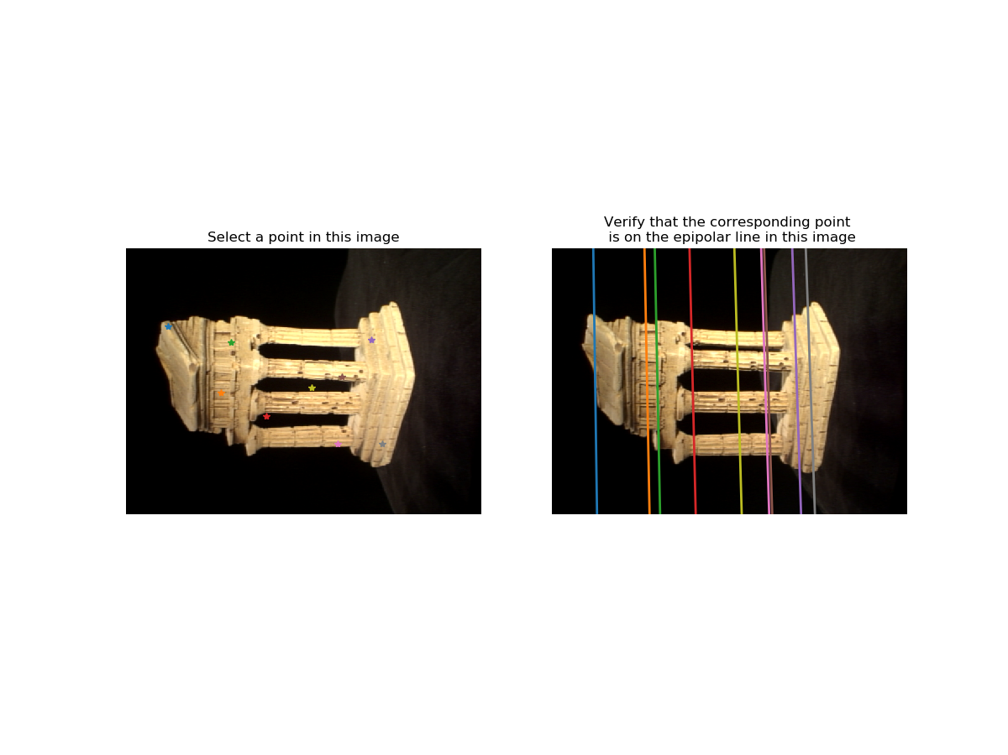

Figure 1 – Sample point and their corresponding epipolarlines in eight-point algorithm.

**Q2.2 The Seven Point Algorithm**

The resultant Fundamental Matrix from seven-point algorithm is:

The image below shows the selected points and corresponding epipolarlines. It can be observed that the lines are not perfect parallel as the ones in Q2.1. This is because the algorithm is based on only seven points, and a bad combination of selections could cause this issue. Ideally, if the seven points could represent all the features in the Fundamental Matrix, the epipolarlines will be parallel.

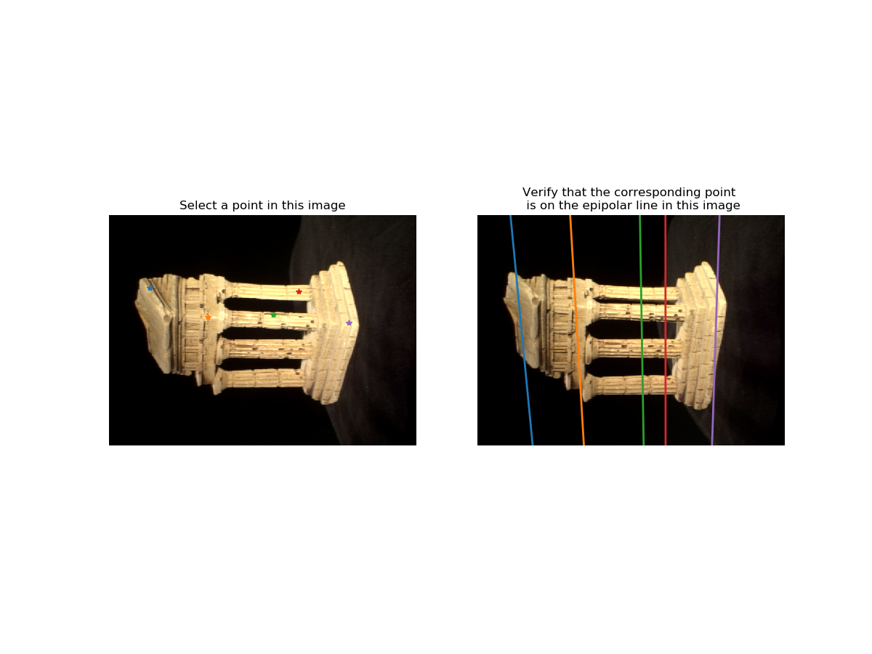

Figure 2 – Sample point and their corresponding epipolarlines in seven-point algorithm.

**Q3.1: Metric Reconstruction: Essential Matrix**

The calculated Essential Matrix are given below:

**Q3.2: Metric Reconstruction: Triangulation**

The expression of matrix can be found in lecture notes, and the exact same form is used in the implementation:

Where and correspond to the first and second element of an image point. Since we have two image points, we can have of these equations in total:

Here we use instead of because camera intrinsics are inculded:

**Q4.1: Epipolar Correspondence**

The results of epipolar correspondences are shown below. The corresponding points are correctly located.

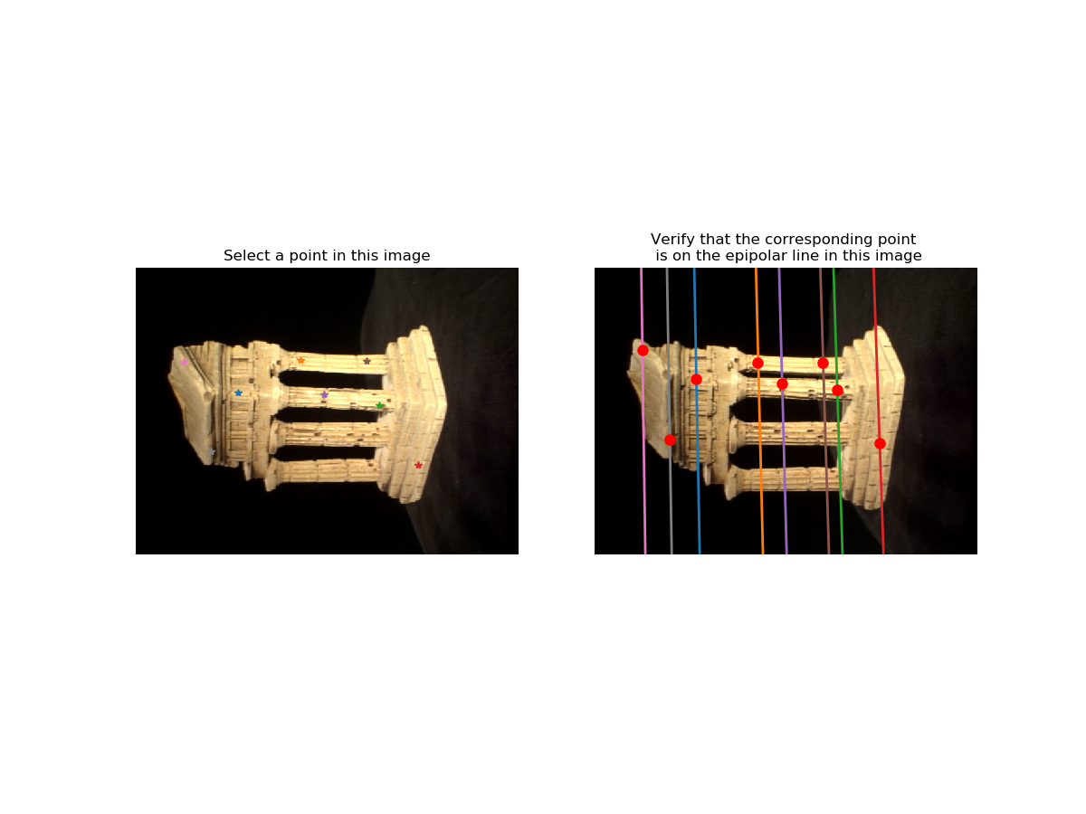

Figure 3 – Sample point and their corresponding epipolarlines and points in eight-point algorithm.

**Q4.2: 3D Visualization**

The screenshots of the resultant 3D visualization are shown below. The shape of the object looks correct.

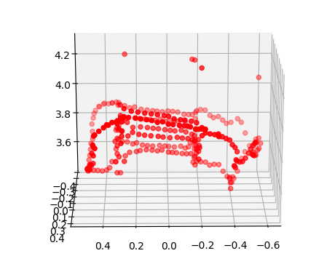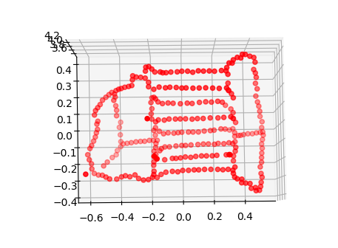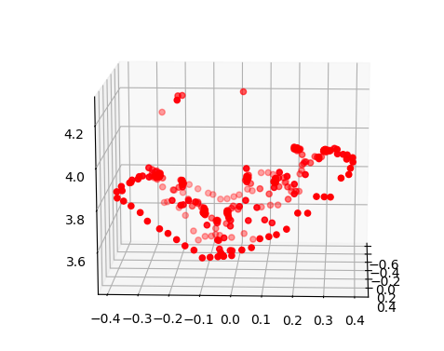

Figure 4 – 3D Visualization of the new points in image 1.